**Corona virus Detector**

A corona virus detector based on Seeed Studio Grove - MLX90615 Digital Infrared Temperature Sensor on the mask.

**How it works…**

There are two detectors on the mask. Each detector is made by the same infrared temperature sensor. And we choose to use Grove - OLED Display 1.12'' V2 to display the temperature data on the mask.

# This mask has the following functions:

* Digital infrared temperature sensor above the mask can detect the self-body temperature in real time and show up the temperature on OLED display that is attached on the mask.
* The detector on the other side can detect the temperature of the person we have contacted.
* If the other person's temperature is normal, the RGB LED ring in the left eye part is green.
* If the other person ’s temperature exceeds 38℃, the RGB LED ring will turn to red color and be accompanied by an alert, indicating that he/she is a potential risk with corona virus , then we will advise him to go to the hospital for test and treatment.

**What we need?**

* Hardware Detector
  1. Arduino Uno
  2. Grove Base Shield V2.0
  3. Grove – Digital Infrared Temperature Sensor
  4. Grove – MP3 V2.0
  5. Battery
  6. Grove – Button
  7. Mono Enclosed Speaker – 2W 6ohm
  8. Grove – OLED Display 1.12” V2
  9. Grove – RGB LED Ring
* Structure
  1. 3mm thick acrylic board
  2. Some glue
* Tools
  1. Hot melt glue gun
  2. Electric soldering iron
  3. 3D printer

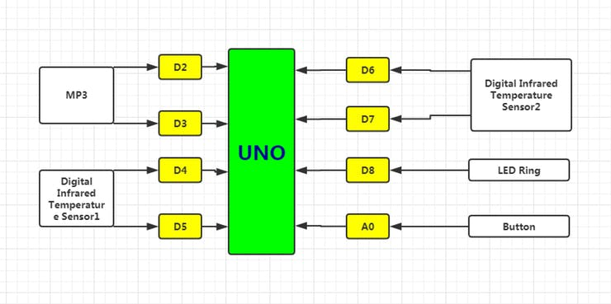

**Finally…**

Because the detection distance of the digital infrared temperature Sensor will lead to different results. We used a distance of about 6mm for detection, so you need to adjust the body temperature formula according to the actual situation of your detection.

This work is actually being modified while trying many different solutions. Now this version is also a bit rough, and a more refined version will be produced in the future. We hope this will be the show-stopper of the event.